Laporan Praktikum 5

1. Source code

matakuliah.php 🡪 controller

view-form-matakuliah.php 🡪 views

pustaka/config/autoload.php

1. URL

<http://localhost/pustaka-booking-rohmat/matakuliah>

1. Capture Output Program

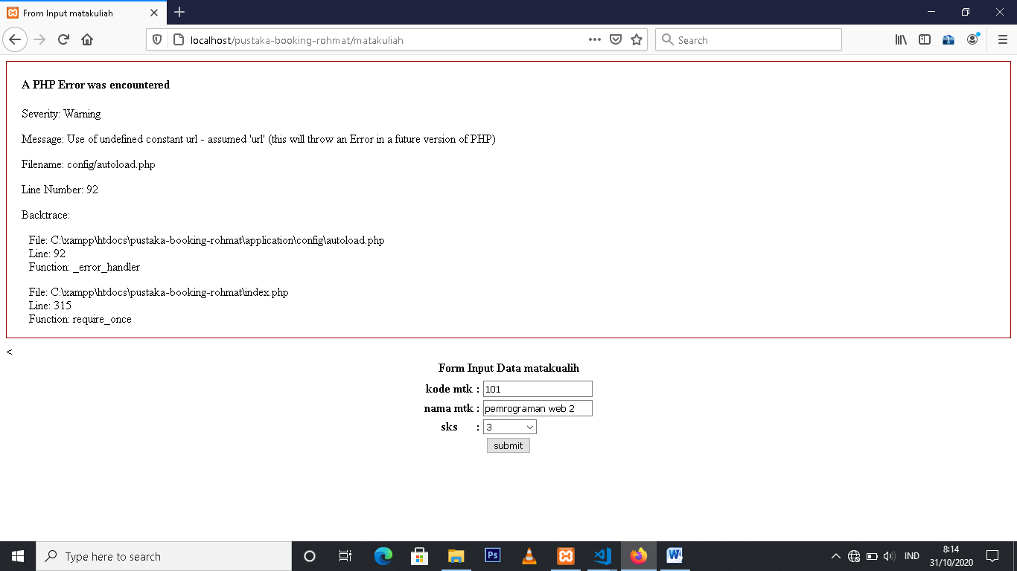

Libraries = form_validation

